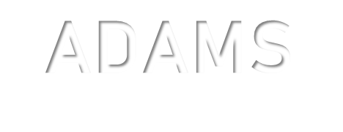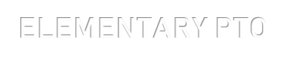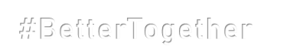

ADAMS
ELEMENTARY PTO
#BetterTogether

2021-2022 PTO Board Members
Co-Chair: Stephanie Miller, stjreed@gmail.com
Co-Chair: Victoria Fricke, vfricke@dreamvacationinc.com
Treasurer: Allison Freeman, Allison_markey@hotmail.com
Secretary: Allison Nixon, nixon.allison.a@gmail.com
AdamsPTO.FT@gmail.com

We are excited to welcome all new and returning families to the 2021-2022 school year at Adams Elementary. We are looking forward to having an exciting, successful and, hopefully, more normal year. Our mission, as a PTO is to foster a nurturing and caring environment that strives for continued parent involvement to help build a better educational experience for our children. Please feel free to reach out to any of the board members directly or contact us via our email address. Our PTO can also be found on Facebook, Adams Elementary PTO.

Regular PTO meetings will be held on the second Tuesday of the month, beginning in September. Location is to be determined, but we hope to meet in person as often as possible. Please watch Facebook for any updates to this schedule that may be needed.

In an effort to keep everyone informed, we will be sending a monthly PTO newsletter home with all students regarding upcoming events and activities. This can also be found on ParentSquare. We look forward to meeting everyone and getting to know you and your family.

Thank you for supporting Adams Elementary PTO!

